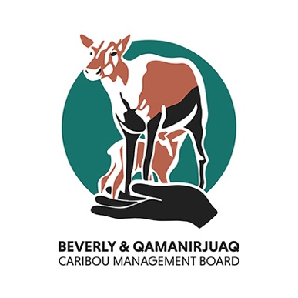
Caribou Connections Fund
Application
Use this template to prepare your application. Once complete, save this document and send it to BQCMB at info@arctic-caribou.com with the subject “Caribou Connections Fund”.
Please type into the spaces provided below.
Applicant information
Applicant name and/or organization:
Community of applicant / organization:
Name of main contact person:
Phone:
Email:
Mailing Address:
Project details
Activity / Project Name:
Who is the activity / project leader?
Activity / project description (3–5 sentences):
Where will your activity / project take place? (1–3 sentences):
What are the start and end dates? (if dates are flexible, please describe):

Partners and participants
Are there other partners or supporters involved? Please describe:
Describe who will participate (Elders, youth, how many, how selected):
How will the activity / project benefit youth and the community?
Is there anything else you want to tell us?

Project Budget
We require applicants to include a project budget using our template below, or to attach one separately. Please be aware that as funds are limited, applicants may not be approved for the full requested amount.
How much funding are you applying for (up to $10,000)?

Category | Description | Estimated Cost ($) | Notes
Wages / Honoraria | E.g., Elder honoraria, youth facilitator wages
Meals | E.g., food for camp, snacks for youth participants
Transportation | E.g., vehicle / skidoo rental, fuel
Accommodation | E.g., hotel rooms, cabins, community accommodations
Equipment / Materials | E.g., tents, hunting gear, craft supplies
Other | E.g., venue rental, translation services
 | Total

Please submit completed applications and any questions about your funding idea to:
info@arctic-caribou.com

